Heart Disease Analysis Report

1. Introduction
Heart disease remains a leading cause of mortality worldwide, making it essential to analyze factors contributing to its prevalence. This report explores patterns, correlations, and risk factors associated with heart disease based on a dataset containing multiple health-related attributes.

2. Dataset Overview
The dataset consists of various features such as BMI, smoking habits, alcohol consumption, history of stroke, physical and mental health, general health, and chronic conditions. The dataset includes 319,794 records and 18 features.

3. Key Insights

3.1 Gender and Heart Disease

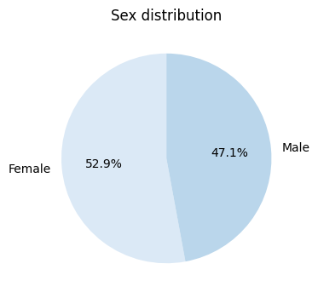
- Insight: Males have a higher probability of developing heart disease compared to females.
- Possible Explanation: This may be due to differences in lifestyle, genetic factors, and higher rates of risk-taking behaviors among men.

3.2 Smoking and Heart Disease

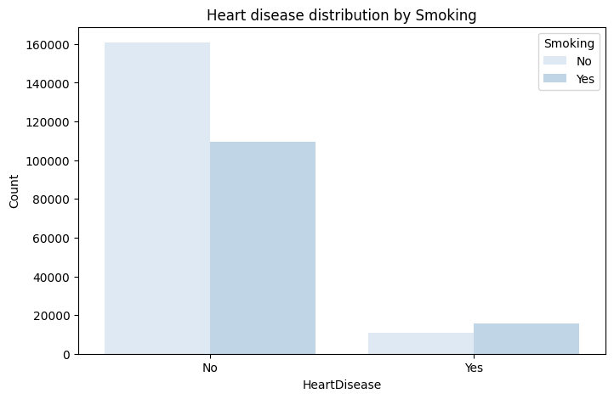

- Insight: Smokers have a higher probability of developing heart disease.
- Possible Explanation: Smoking damages blood vessels, increases blood pressure, and contributes to plaque buildup in arteries, leading to cardiovascular issues.

3.3 Alcohol Consumption and Heart Disease

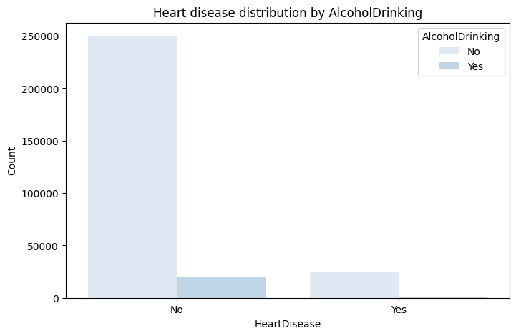
- Insight: Alcohol consumption does not show a significant impact on heart disease.
- Possible Explanation: While excessive alcohol consumption is linked to heart disease, moderate drinking may not have a direct correlation.

3.4 Stroke and Heart Disease
- Insight: History of strokes does not show a significant impact on heart disease in this dataset.
- Possible Explanation: Although stroke and heart disease share common risk factors, stroke alone may not be a strong predictor of heart disease.

3.5 Age and Heart Disease

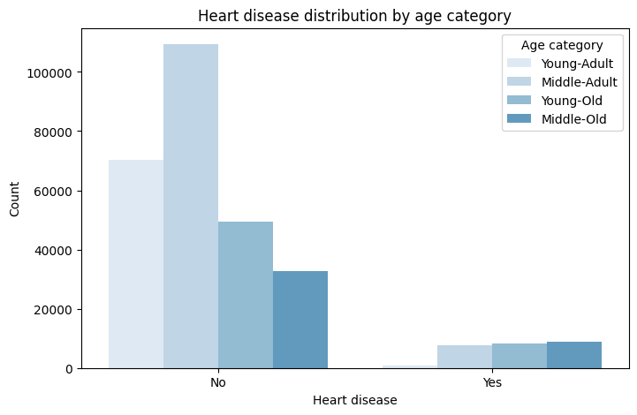
- Insight: Older individuals have a higher probability of developing heart disease.
- Possible Explanation: Aging leads to the natural wear and tear of the cardiovascular system, increasing susceptibility to heart disease.

3.6 Diabetes and Heart Disease

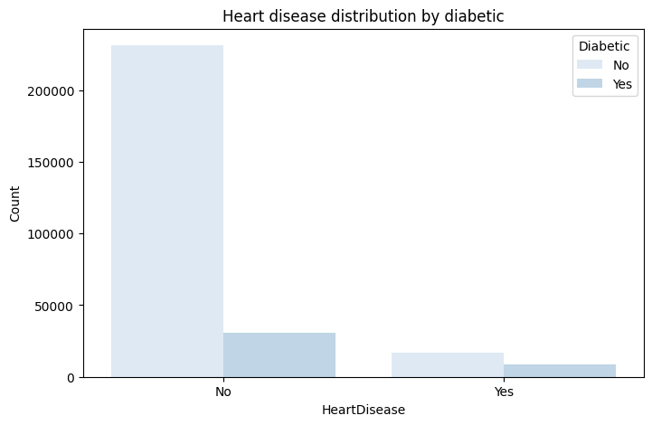
- Insight: Diabetes does not show a significant impact on heart disease in this dataset.
- Possible Explanation: While diabetes is a known risk factor, the dataset may not capture the severity and duration of diabetes cases, leading to a weaker correlation.

3.7 General Health and Heart Disease

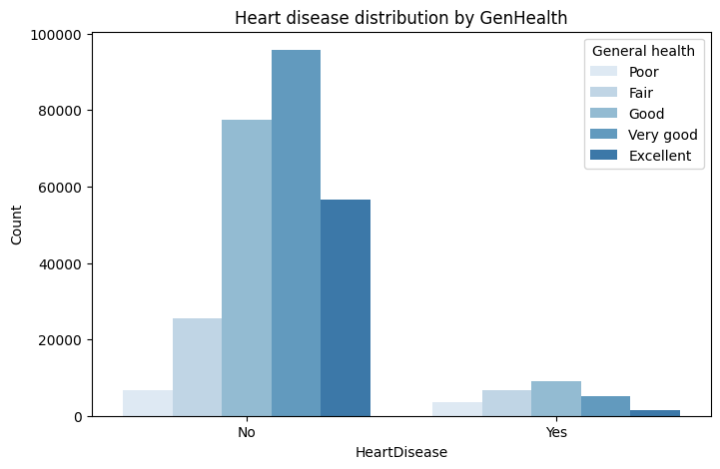
- Insight: Individuals with lower general health have a higher probability of developing heart disease.
- Possible Explanation: Poor overall health often reflects an accumulation of risk factors such as poor diet, lack of exercise, and other underlying conditions.

3.8 Asthma and Heart Disease
- Insight: Asthma does not show a significant impact on heart disease.
- Possible Explanation: While respiratory conditions may strain the heart over time, asthma alone may not be a direct contributor to heart disease.

3.9 Kidney Disease and Heart Disease
- Insight: Kidney disease does not show a significant impact on heart disease in this dataset.
- Possible Explanation: While kidney disease is linked to cardiovascular problems, the dataset may not sufficiently highlight its role in heart disease development.

3.10 Skin Cancer and Heart Disease
- Insight: Skin cancer does not show a significant impact on heart disease.
- Possible Explanation: Skin cancer is primarily linked to sun exposure rather than cardiovascular health.

3.11 Sleep Quality and Heart Disease
- Insight: People with good sleep quality are less likely to develop heart disease.
- Possible Explanation: Proper sleep is essential for heart health, regulating blood pressure, reducing stress, and supporting overall cardiovascular function.

4. Conclusion and Recommendations

4.1 Conclusion
The analysis of this dataset highlights key factors influencing heart disease risk. While smoking, gender, age, and general health show strong correlations with heart disease, factors like alcohol consumption, stroke history, diabetes, asthma, kidney disease, and skin cancer show little to no significant impact.

4.2 Recommendations
- Encourage smoking cessation programs to reduce heart disease risk.
- Promote regular health checkups for older adults to detect early signs of cardiovascular issues.
- Improve public awareness on the importance of general health in preventing heart disease.
- Encourage proper sleep habits as a preventive measure against heart disease.
- Further studies should explore underlying factors related to diabetes and kidney disease to assess their long-term impact on heart health.

